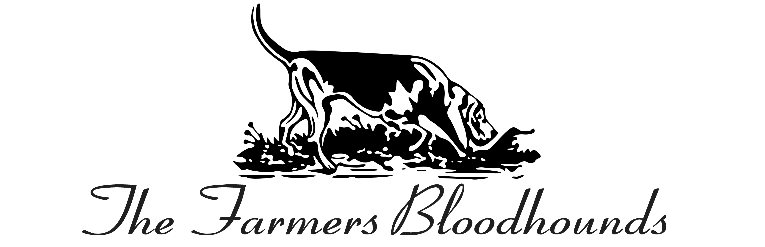
SAFETY CODE
CONDITIONS APPLYING TO ALL THOSE WHO HUNT The Farmers Bloodhounds
General
Riding to Bloodhounds is a high-risk sport. From time to time it is inevitable that accidents will happen, whether or not it is the fault of the rider or of any of those otherwise concerned, including ourselves. For this reason we make it a condition that anyone coming out with us must have read carefully and must observe the safety requirement, which follow
Insurance Recommendations We strongly recommend that:
- You insure yourself whilst out with the Bloodhounds against all risks including any claims which may be made against you arising out of your participation in the day s hunting, from injury, loss or damage caused to any rider or third party sustained in the course of or as a result of hunting however or by whomsoever.
- You insure yourself and your horse against all risk including injury, loss or damage sustained in the course of or as a result of hunting however or by whomsoever caused, including ourselves and whether or not anyone is to blame.
We draw to your attention that: If you become a member of The Countryside Alliance, you can through such membership, readily obtain suitable insurance cover. If you do not already have the cover as above recommended you should be in touch with The Countryside Alliance immediately in order to put this into effect.
Safety Requirements
The requirements that follow are intended to minimise the risk of those involved and are given in the best interest of the rider.
It is important that you realise that the type of Lines that we are now riding is suitable only for experienced riders and experienced horses. Accordingly, if you wish to bring out a horse of limited experience, you should not do so unless you have had a discussion with one of the Masters who is responsible for the day in order to find out if the Line is suitable for your horse. There will be Second Field Masters to escort less experienced riders/horses.
A Safety Officer and Assistant Safety Officer to be appointed to help ensure this Safety Code is complied with. If you have doubt about any aspect relating to safety, please ensure you clarify this with the safety Officer of the Day.
HEADGEAR - FOR BOTH THOSE HUNTING WITH THE TFB AND ANY MOUNTED ASSISTANTS WHENEVERRIDING IN THE COURSE OF THEIR DUTIES WITH HOUNDS. The headgear, which should be worn, is a hunting cap of the established crash helmet variety with fitted safety harness conforming with British Safety Standards
JUMPING-Whenever possible spread out at a fence and never ride immediately behind the horse in front. Always ride straight at a fence. A horse ridden at an angle may cross the path of others and put them at risk.
If your horse attempts to refuse or refuses, do your best to keep him going on a straight line, do not run down the fence. When a horse in front of you has fallen, you must jump the fence at a safe distance away from the faller.
VISTORS/GUESTS -The onus is on a member to ensure his visitor / guest is suitable to come out and is aware of all conditions, before they become a visitor / guest.
LOOSE HORSES -These must be caught at the earliest possible moment. If necessary the field must stop to enable this to be done.
GATES -All Gates must be shut. If you go through a gate either shut it or ensure that somebody behind you will do so.
KEEPING TO THE LINES -The direction of the line has been carefully worked out with the Farmers beforehand. If by any chance you get left behind, follow either the path of the Line or go back the way you have come. DO NOT take a Line of your own.
By attending any meet with The Farmers Bloodhounds, the attendees acknowledge and agree that although The Farmers Bloodhounds have taken every precaution and followed government guidance, it is impossible to eliminate all risks and there is a potential for unintended transmission of COVID-19. All those attending must minimise the risk to themselves and others by complying with government guidelines as well as any on site instructions and signage. The Farmers Bloodhounds have the right to refuse entry or request departure from the premises should there be any breach of the COVID-19 protocols put in place.
SAFETY DECLARATION
In consideration of being permitted to hunt with The Farmers Bloodhounds I confirm on my own behalf that:
I recognise that hunting is a high-risk sport and that, whilst The Farmers Bloodhounds through its officials and employees will endeavour to reduce the risks for those hunting, it cannot always guarantee that its risk reduction system will have been fully complied with or that some human error will not occur. I have read and shall comply with the conditions of hunting with The Farmers Bloodhounds.
The value of horses differs significantly and cannot be expected to be known by the Masters and Officers of The Farmers Bloodhounds. Accordingly, in the event of injury or death to my horse or any other horse ridden by me, whether due in part or full to any error, neglect or default on the part of The Farmers Bloodhounds, its officials or employees, I will not hold The Farmers Bloodhounds its officials or employees responsible for such injury or death or any consequential expenses. I further agree that it is my sole responsibility to arrange effective insurance cover in respect thereof and (where I do not myself own the horse which I am riding) to indemnify and save harmless The Farmers Bloodhounds its official or employees against any claim or claims made by the owner of any horse ridden by me.
DATA PROTECTION
By ticking the box above, I understand that the personal information provided is for The FBH only for emergency purposes and will not be shared with any 3rd party.
I HAVE READ TFB SAFETY CONDITIONS AND FULLY UNDERSTAND AND WILL COMPLY WITH THEM.

SIGNED………………………………………………………….Date:………/…………/…………..

NAME PRINTED IN CAPITALS…………………………………………………………………….
ADDRESS …………………………………………………………………………………………….
…………………………………………………………………………………………………………
…………………………………………………………………..POSTCODE……………………….
E-MAIL………………………………………………………………………………………………..
TELEPHONE NO……………………………………………………………………………………..
EMERGENCY CONTACT NAME & NUMBER
.................................................................................................................................................................

